LABORATORY WORK 1

ER-Diagram of the International Airport Booking System
Course: Databases
Laboratory Work: 1 – ERD Diagram
System: International Airport Booking System

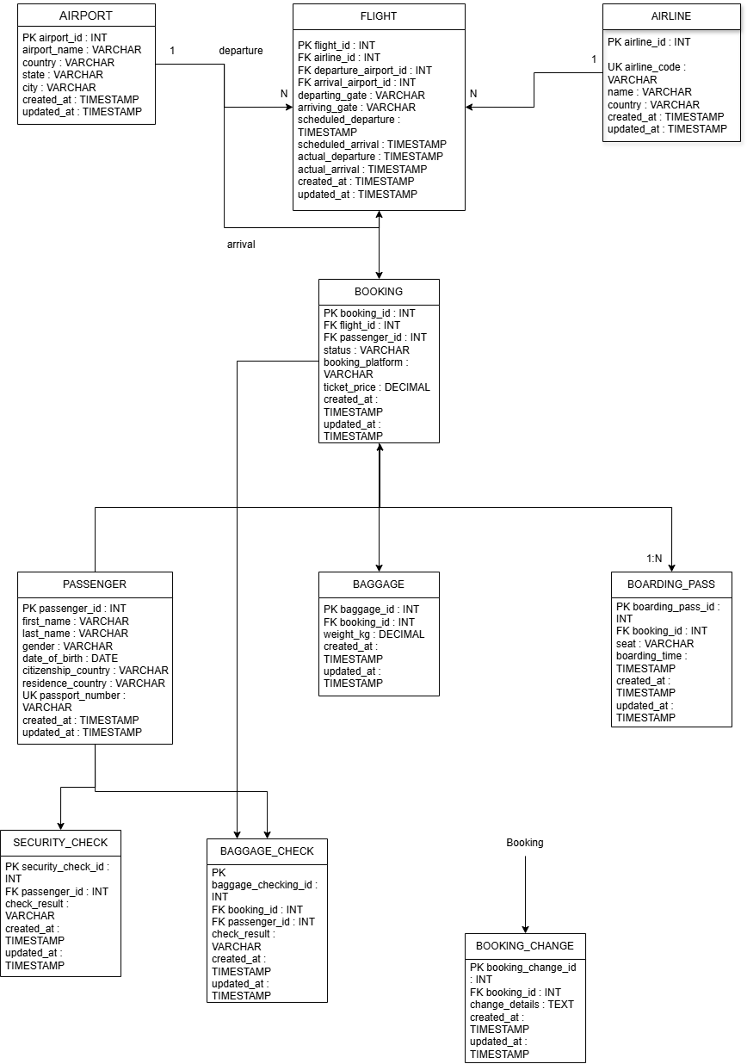

1. Purpose of the Database
The International Airport database is designed to manage airports, airlines, flights, passenger bookings, boarding passes, baggage, baggage checks, security checks, and booking changes. Primary and foreign keys maintain data integrity and establish relationships between entities.

2. Entities
The system contains the following entities:
- AIRPORT – stores airport names and location information.
- AIRLINE – stores airline codes, names, and countries.
- FLIGHT – stores scheduled and actual flight information.
- PASSENGER – stores personal and passport information.
- BOOKING – stores passenger flight bookings, status, platform, and ticket price.
- BOOKING_CHANGE – stores changes made to bookings.
- BOARDING_PASS – stores boarding pass information, seat, and boarding time.
- BAGGAGE – stores baggage information and weight.
- BAGGAGE_CHECK – stores baggage checking results.
- SECURITY_CHECK – stores passenger security check results.

3. Relationships and Cardinality
The entities in the database are connected through the following relationships:
- AIRPORT (1) — (N) FLIGHT – one airport can be the departure or arrival airport for many flights.
- AIRLINE (1) — (N) FLIGHT – one airline can operate many flights.
- FLIGHT (1) — (N) BOOKING – one flight can have many bookings.
- PASSENGER (1) — (N) BOOKING – one passenger can have many bookings.
- BOOKING (1) — (N) BOOKING_CHANGE – one booking can have zero or many changes.
- BOOKING (1) — (0..1) BOARDING_PASS – one booking can have zero or one boarding pass.
- BOOKING (1) — (N) BAGGAGE – one booking can have multiple baggage records.
- BOOKING (1) — (N) BAGGAGE_CHECK – one booking can have multiple baggage-check records.
- PASSENGER (1) — (N) BAGGAGE_CHECK – one passenger can have multiple baggage-check records.
- PASSENGER (1) — (N) SECURITY_CHECK – one passenger can have multiple security-check records.

4. Keys and Constraints
Each entity has a Primary Key (PK). Foreign Keys (FK) are used to connect related entities and maintain referential integrity.
The main foreign keys are:
- FLIGHT → airline_id, departure_airport_id, arrival_airport_id
- BOOKING → flight_id, passenger_id
- BOOKING_CHANGE → booking_id
- BOARDING_PASS → booking_id
- BAGGAGE → booking_id
- BAGGAGE_CHECK → booking_id, passenger_id
- SECURITY_CHECK → passenger_id
The attributes airline_code and passport_number are defined as UNIQUE, which means that duplicate values are not allowed.
Required attributes are marked as NOT NULL in the ER diagram.

5. ER Diagram
The ER diagram represents the structure of the International Airport database. It contains all identified entities, their attributes, primary keys, foreign keys, and relationships with cardinality constraints.

6. Legend
- PK – Primary Key
- FK – Foreign Key
- UK – Unique Key
- NOT NULL – Required attribute
- 1:N – One-to-Many relationship
- 0..1 – Zero or One relationship

Conclusion
The ERD represents the main structure of the International Airport database. It shows the entities, their attributes, relationships, keys, and cardinalities required to manage airport operations and passenger bookings. The database structure helps maintain data integrity and provides clear connections between flights, passengers, bookings, baggage, and security-related information.

